The mainstream music at the beginning of the 21st century, though followed the natural trend of music over the decades, the few years before that showed a great contrast in styles, themes and genre. Due to the emergence of new styles, artists of the old genre adapted these styles of using catchy rhythms with enjoyable lyrics to gain popularity. In addition to the emergence of new themes and styles, everything about the way we listen to music changed. The technological revolution that happened at the turn of the century made access to music much more than ever before. The MPEG-1 audio, web-based program like Napster enabled the use of MP3 files for easy sharing made music easily accessible without actually paying for it. Before this time, people used to carry huge wallets of CDs with songs. The focus was then shifted from a question of space to a question of time with easy access to music. People know a lot about music since then, and record companies, music producers, artists are trying to figure out strategies to sell more records based on user experience.

Problem Statement:

The music lover has a range of music genre they listen to and are looking for songs that are fresh and have a nice rhythm with enjoyable lyrics. The artists, music producers and record companies are on the other end of the aisle trying to captivate music lovers with their new offerings.

The vision is that any music that is produced needs to be well received without losing peoples interest before making a profit.

There is so much music content out there that the record companies cannot ignore the interests of music lovers which would result in lost revenue, business and reputation.

We will use the method of breaking down the music by genre, artists and songs to capture the interest of the music population to deliver better records.

Blog

The project "Are you entertained-The music of the '00s" is about the Billboard top 100 chart data. The data was collected to analyze what made a hit soar to the top of the charts, and how long they stayed there.

Weekly ranking of songs by 228 artists from 10 genre that made it to the top 100 list are represented in each row of the table. A total of 317 songs made it to the list with at least one week on the top 100 chart.

Why the '00s?

The mainstream music at the beginning of the 21st century, though followed the natural trend of music over the decades, the few years before that showed a great contrast in styles, themes and genre. Due to the emergence of new styles, artists of the old genre adapted these styles of using catchy rhythms with enjoyable lyrics to gain popularity. In addition to new themes and styles, everything about the way we listen to music changed. The technological revolution that happened at the turn of the century made access to music easier than ever before. The MPEG-1 audio, web-based program like Napster enabled the use of MP3 files for easy sharing made music easily accessible without actually paying for it. Before this time, people used to carry huge wallets of CDs with songs. With easy access to music the focus shifted from a question of space to a question of time. People know a lot about music since then, and record companies, music producers, artists were trying to figure out strategies to sell more records based on user experience.

The music lover has a range of music to listen to and are looking for songs that are fresh and have a nice rhythm with enjoyable lyrics. The artists, music producers and record companies are on the other end of the aisle trying to captivate music lovers with their new offerings.

The vision is that any music that is produced needs to be well received without losing peoples interest before making a profit. There is so much music content out there that the record companies cannot ignore the interests of music lovers which would result in lost revenue, business and reputation.

We will use the method of breaking down the music by genre, artists and songs to capture the interest of the music population to deliver better records.

The total number of 317 track records are categorized into into 10 genre with 137 records from Rock and 74 from Country genre.

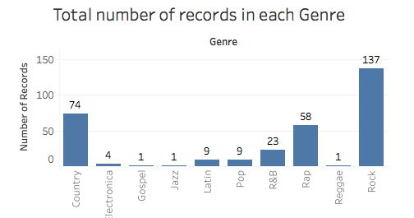

The project "Are you entertained-The music of the '00s" is about the Billboard top 100 chart data. The data was collected to analyze what made a hit soar to the top of the charts, and how long they stayed there.

Weekly ranking of songs by 228 artists from 10 genre that made it to the top 100 list are represented in each row of the table. A total of 317 songs made it to the list with at least one week on the top 100 chart.

Why the '00s?

The mainstream music at the beginning of the 21st century, though followed the natural trend of music over the decades, the few years before that showed a great contrast in styles, themes and genre. Due to the emergence of new styles, artists of the old genre adapted these styles of using catchy rhythms with enjoyable lyrics to gain popularity. In addition to new themes and styles, everything about the way we listen to music changed. The technological revolution that happened at the turn of the century made access to music easier than ever before. The MPEG-1 audio, web-based program like Napster enabled the use of MP3 files for easy sharing made music easily accessible without actually paying for it. Before this time, people used to carry huge wallets of CDs with songs. With easy access to music the focus shifted from a question of space to a question of time. People know a lot about music since then, and record companies, music producers, artists were trying to figure out strategies to sell more records based on user experience.

The music lover has a range of music to listen to and are looking for songs that are fresh and have a nice rhythm with enjoyable lyrics. The artists, music producers and record companies are on the other end of the aisle trying to captivate music lovers with their new offerings.

The vision is that any music that is produced needs to be well received without losing peoples interest before making a profit. There is so much music content out there that the record companies cannot ignore the interests of music lovers which would result in lost revenue, business and reputation.

We will use the method of breaking down the music by genre, artists and songs to capture the interest of the music population to deliver better records.

The total number of 317 track records are categorized into into 10 genre with 137 records from Rock and 74 from Country genre.

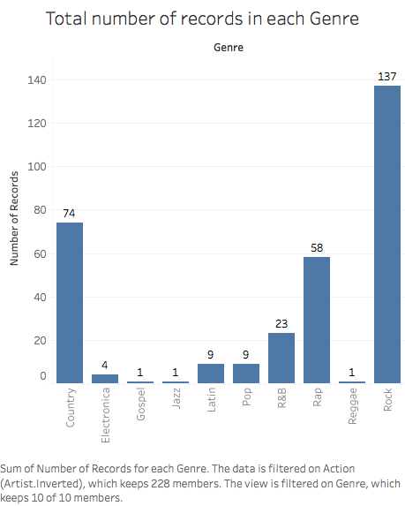

A snapshot of the first week ranking is shown below where each row represents one track by an artist the made it into the top 100 chart.

|  | **Artist** | **Track** | **Week #** |
| --- | --- | --- | --- |
| **0** | Destiny's Child | Independent Women Part I | x1st.week | 78.0 |
| **1** | Santana | Maria, Maria | x1st.week | 15.0 |
| **2** | Savage Garden | I Knew I Loved You | x1st.week | 71.0 |
| **3** | Madonna | Music | x1st.week | 41.0 |
| **4** | Aguilera, Christina | Come On Over Baby (All I Want Is You) | x1st.week | 57.0 |
| **5** | Janet | Doesn't Really Matter | x1st.week | 59.0 |
| **6** | Destiny's Child | Say My Name | x1st.week | 83.0 |
| **7** | Iglesias, Enrique | Be With You | x1st.week | 63.0 |
| **8** | Sisqo | Incomplete | x1st.week | 77.0 |
| **9** | Lonestar | Amazed | x1st.week | 81.0 |

The highest ranking a record in a particular genre got to on the chart is shown below with most genre having ranks less than 10.

Hypothesis: If the ranking of a record is below 20 after 20 weeks, it will go on to stay the longest on the billboard chart for the year.

Records that stayed the logest on the billboard chart in decreasing order is represented below. The chart below shows records that stayed atleast 25 weeks on the billboard charts

The highest ranking the above songs got to on the billboard chart is shown below. According to the hypothesis, most of these songs have to be in the top 20 after being on the billboard charts for 20 weeks.

The highest ranking a record in a particular genre got to on the chart is shown below with most genre having ranks less than 10.

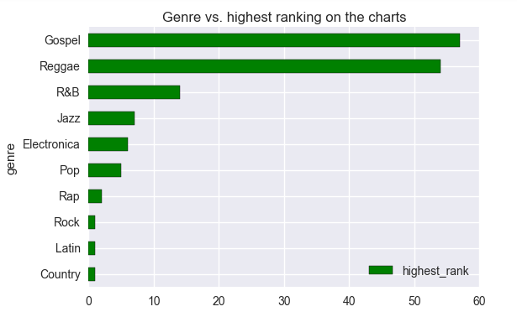

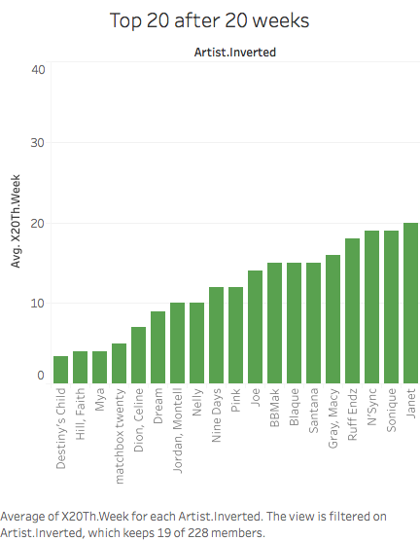

Executive Summary:  
1. The data represents the songs that reached the billboard top 100 list in any week of the year 2000.  
2. The data represents 228 artists and 317 songs across 10 genres with more than 65% of songs coming from Rock and Country genres.  
3. There is no strong dependence of the month the song was released to the number of weeks it stayed on the billboard charts.  
4. The first week rank of the song does not correlate with how long the song was on the billboard chart. Songs that stayed more than 20 weeks on the charts typically reached the highest rank on the charts. More specifically, top 20 songs at 20 weeks usually went on to stay the longest on the charts.  
5. Songs that reached their peak ranking in less than 10 weeks were on the charts for not more than 20 weeks.